Learning Journal Unit 2
- What concepts (only the names) did you need to accommodate the concept of lines and quadratic functions in your mind?
To understand lines functions, I needed to notes that they produce straight-line graphs with the standard equation $y=mx+c$, where x and y are the independent and dependent variables respectively, m represents the gradient or slope, and c represents the y-intercept. On the other hand, understanding the quadratic functions required me note that they produce a parabolic shape with the standard equation $y=ax^{2}+bx+c$.
- What are the simplest line and quadratic function you can imagine?
The simplest line function is $y = x$, where 1 is the slope and 0 is the y-intercept. The line function will produce a straight line passing through the origin. On the other hand, the simplest quadratic function is $y = x^{2}$, which will produce a parabolic graph or a U-shaped curve that is symmetrical about the y-axis. The minimum point of the function, also known as the vertex is located at the origin.
- In your day to day, is there any occurring fact that can be interpreted as lines and quadratic functions?
In educational context, a linear function can be represented by the relationship between the revenue collected as school fees and the number of students enrolled in a school. If the school increases, the number of students enrolled in a school is likely to decline. This information can be represented by a linear function as$n=mr+c$where n and r represent the number of students and revenue collected from each child respectively. Finally, c will represent the y-intercept.
On the other hand, an example of quadratic function can be derived from the football context represented by the projectile motion of a ball be kicked by a player, as shown below.
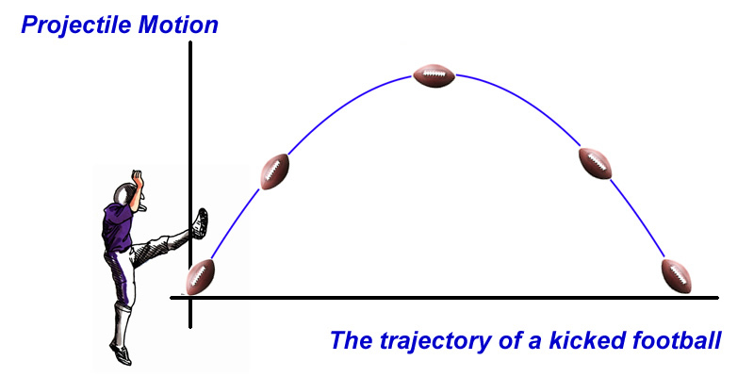
The figure makes clear that the projectile motion is a fairly prevalent motion in the sport. When the ball is kicked, there are the two situations that involve the most projectile motion. In both cases, the ball forms a parabolic shape, which indicates that as it moves upward, its acceleration increases; but, as it reaches the parabola's summit, it decreases to zero and comes to a sudden stop. Finally, as it moves downward, its acceleration increases. The ball maintains the same velocity during the entire motion. The trajectory of the kicked ball can be represented using a quadratic function $f\left(t\right)=-at^{2}+bt+c$, where the maximum height the ball reached is at the vertex $(h,k)$ can be determined by obtaining $f(h)$, since h can be found using the formula $h=-\frac{b}{2a}$.
- What strategy are you using to get the graph of lines and quadratic functions?
When graphing lines, you can start by finding two points and connecting them to create a straight line. For quadratic functions, you can determine the vertex and plot a few additional points to sketch the parabola accurately. Understanding the key features of lines (slope and y-intercept) and quadratics (vertex and direction of opening) helps in graphing and interpreting them effectively. Additionally, graphing calculators and computer software can be valuable tools for visualizing these functions accurately.

